I collected a balanced dataset of 400 Ugandan news items. Exploratory analysis shows meaningful linguistic structure, balanced class distribution, realistic language use, and credible labeling sources. The data is sufficient and suitable for training machine learning models for fake news detection.
The dataset is perfectly balanced with an equal number of fake and true news articles (200 each). This balance prevents model bias toward a dominant class and supports fair evaluation of classification performance.
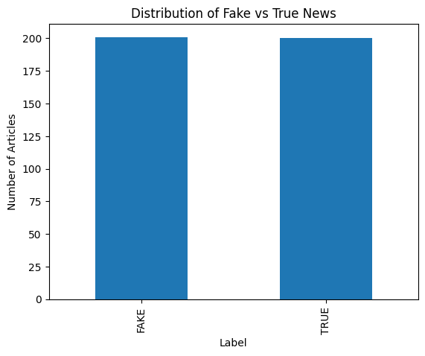

Fake and true news articles show overlapping but distinct text-length distributions. This indicates that classification cannot rely on length alone and requires semantic and linguistic features, validating the need for NLP-based models.
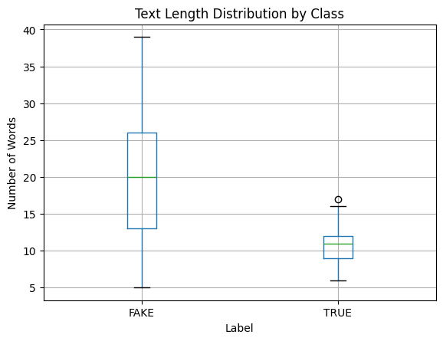

The dataset includes English and mixed-language content (English with Swahili/local language influence), reflecting real Ugandan online communication patterns. This supports the study’s localization objective.

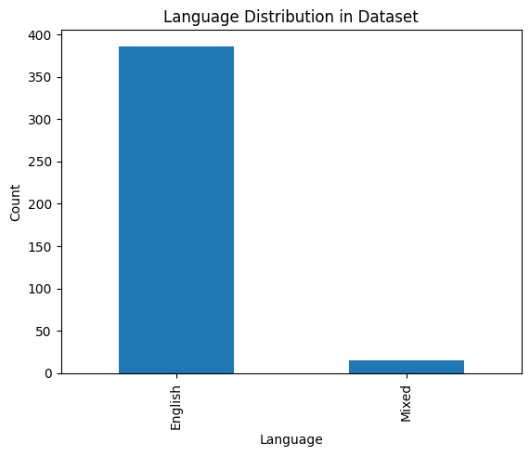

Fact-checking platforms dominate fake news labels, while established news organizations dominate true news labels.
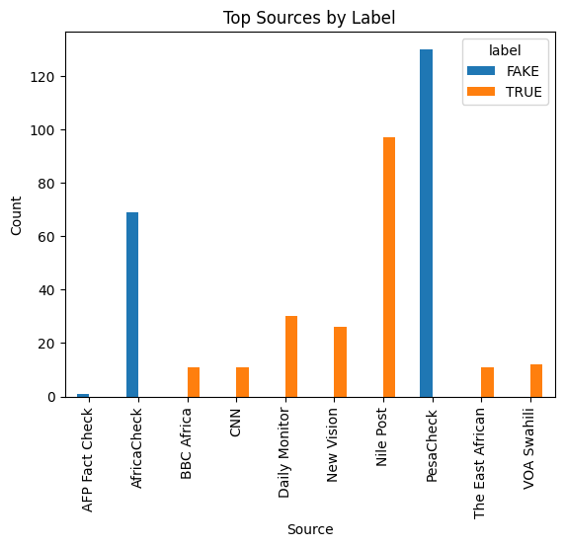

Preliminary lexical differences exist between fake and true news, indicating that word usage patterns can support automated classification.

Phase 3
The dataset contains headlines and short news statements, typical of social media and online news dissemination in Uganda.

Text preprocessing was applied to normalize the data, remove noise, and retain semantic meaning. English stopwords were removed while preserving mixed-language expressions to maintain local linguistic context.

PHASE 4: FEATURE EXTRACTION (TF-IDF)

